MSCD640
Lab 3

Name: Rohan Purohit

Date: Oct 4 2015

-----------------------------------------------------------------------------------

The purpose of this lab is to become familiar with the following types of basic DBA tasks:
- Understanding the data dictionary
- Creating and managing large objects
- Creating and managing partitioned tables and indexes
- Using Data Pump
- Creating and managing external tables
- Creating and managing materialized views

Read Chapters 10 through 15 in the book before starting this lab.

These labs focus on how to perform DBA tasks from the SQL*Plus command prompt. These labs do not show how to perform tasks from Enterprise Manager. I prefer that students learn basic DBA tasks from SQL*Plus for the following reasons:
- Not all environments have Enterprise Manager installed, therefore you’ll need to know how to perform basic DBA tasks from the SQL command prompt.
- Performing the tasks manually from SQL gives you a better understanding of the underlying SQL used to accomplish DBA tasks.
- If you can perform DBA tasks from SQL, then you’ll have no problems understanding how to perform the same tasks in Enterprise Manager.

To get an “A” grade on this lab:
- Answer all questions.
- Provide output of steps that require you to perform a task. The output can be a spool file, cut and paste from the screen to a word document, screen shots. I need to see something to verify that you ran the labs. I’m expecting you to turn in a word document that contains each question and also the corresponding answers to questions asked and output from SQL statements.

- Longer code required for labs can be found on the ORA05 database server under /home/mscd640/MSCD640_Scripts. If a script file is required to complete a lab exercise it will be noted in the exercise itself. Some exercises will require the student to type in a defined code snippet found in the lab exercise. If cutting and pasting code from the Lab document to a SQL session on the database server be sure to review pasted code for possible conversions of single quote marks (‘) to periods (.). If an undesired symbol conversion happens the student will need to correct the code prior to submitting the statement again. If, when submitting code, an SP error is returned, this indicates a syntax error typically due to a missing semi-colon, single-quote mark, or misspelled object name, identifier, variable, or clause.

-----------------------------------------------------------------------------------
Lab 3, Part 1: Data Dictionary Basics
Read Chapter 10 in the book.

- CD to your student directory and logon to the database as sysdba.
- Logon to the Database server ora05 through putty on the Regis Citrix Receiver website.

- From the operating system issue a cd command to change your current location to your student directory.
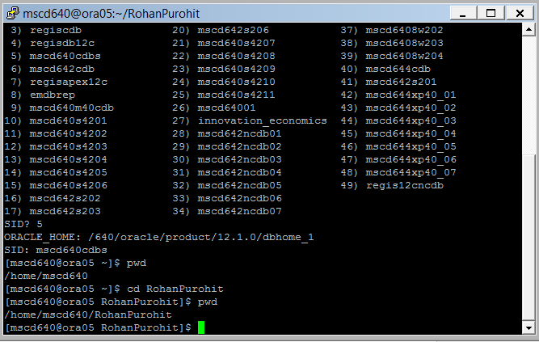
- From the operating system, login to the ROOT container database as sysdba.
Ex:[mscd640@ora05 ~]$ sqlplus / as sysdba

- Display the logged on user.
Ex: SQL> show user

- Display the current container name.
Ex: SQL> show con_name
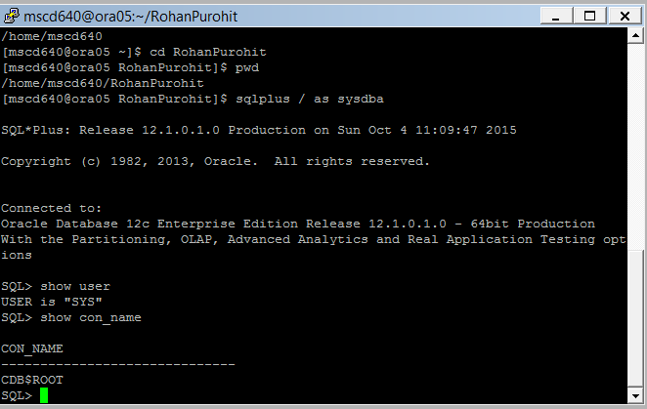

- Query the V$PDBS view to determine the current status of your PDB.
Ex: SQL> select name,open_mode from v$pdbs
where name = ‘your pdb name in CAPS’;
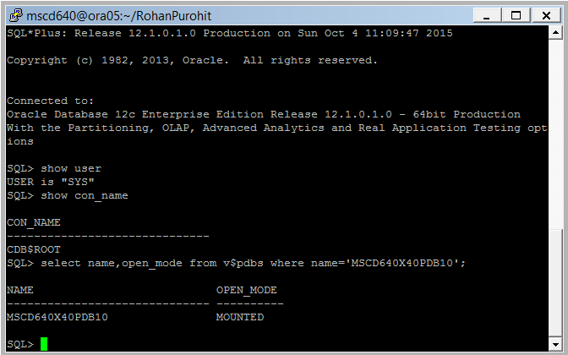
NOTE: If your student PDB is in an OPEN mode skip to (g), otherwise continue with the steps below.

    - At the sql prompt type display the current container you connected to when logging onto the database. This should be the root container.

    - From your current SQL session set the container to your assigned PDB:
Replace xx in the example with your assigned pdb number.
Ex: SQL> alter session set container = msc640xpdbxx;

    - At the sql prompt type display the container name for your PDB. Note the name for future reference.
Ex: SQL> show con_name <no semi-colon required>

    - Display the container id number assigned to your PDB.
Ex: SQL> show con_id <no semi-colon required>

    - Issue an ALTER PLUGGABLE DATABASE command to open the pdb.
Ex: SQL> alter pluggable database open;

    - Query the V$PDBS view contained in the view. There should only be one record present for your PDB.
Ex: SQL> select con_id,
name, open_mode, open_time
from v$pdbs;
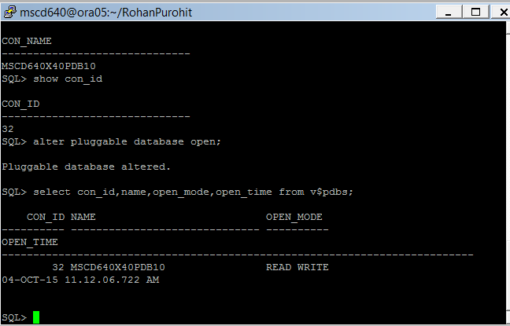
    - From the SQL prompt connect as sysdba.
Ex: SQL> conn / as sysdba
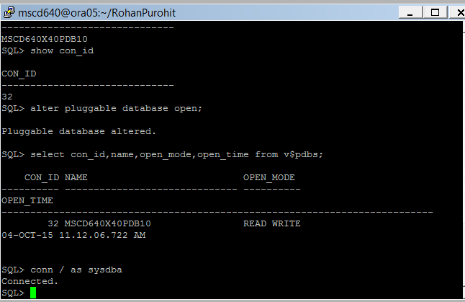
- Go to exercise 2.
-----------------------------------------------------------------------------------

2. Display the SQL underlying the DBA_VIEWS view.
See pages 260-261 in the book.

SQL> set long 5000
SQL> select text from dba_views where view_name='DBA_VIEWS';
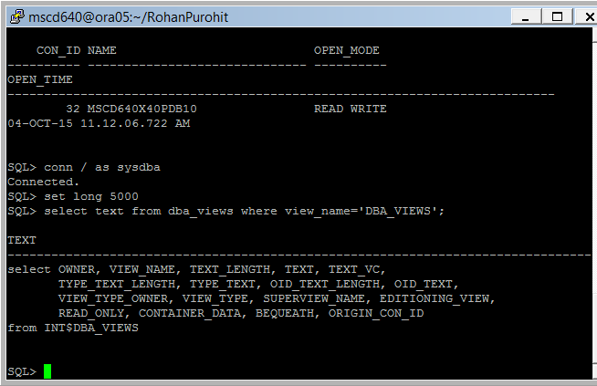

-----------------------------------------------------------------------------------

3. Display the definition of the V$CONTROL_FILE view.
See pages 262 in the book.
Ex: SQL> select
view_definition
from v$fixed_view_definition
where view_name='V$CONTROLFILE';
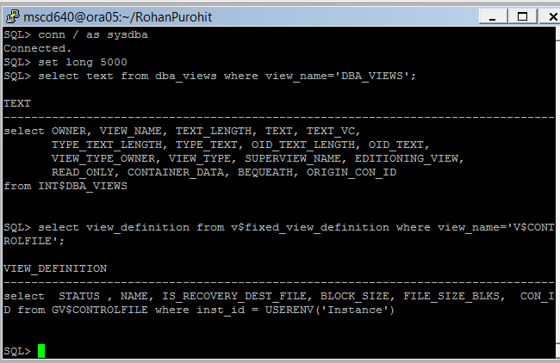
----------------------------------------------------------------------------------
4. What is the purpose of the DICTIONARY views?
See pages 266-269 in the book.
The dictionary view stores the names of the data dictionary views.
-----------------------------------------------------------------------------------

5. Use the dictionary view to display information about materialized view related data dictionary structures.
See page 267 in the book.

Ex: SQL>select
table_name
,comments
from dictionary where table_name like '%MV%';
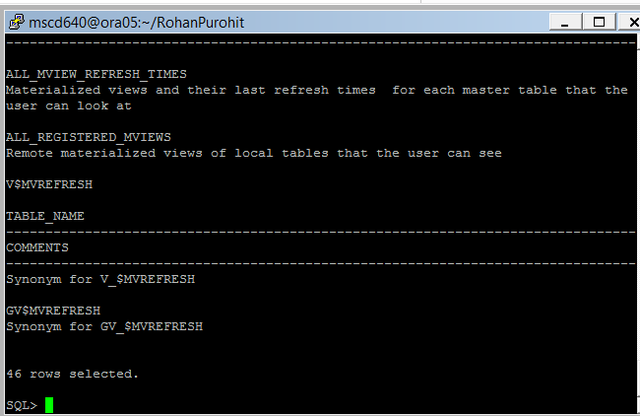

6. Query the DUAL table for user and instance information.
a. Display information about the currently connected user.
See pages 267-268 in the book.
Ex: SQL> select sys_context('USERENV','CURRENT_USER') usr,
sys_context('USERENV','AUTHENTICATION_METHOD') auth_mth,
sys_context('USERENV','HOST') host,
sys_context('USERENV','INSTANCE_NAME') inst
from dual;
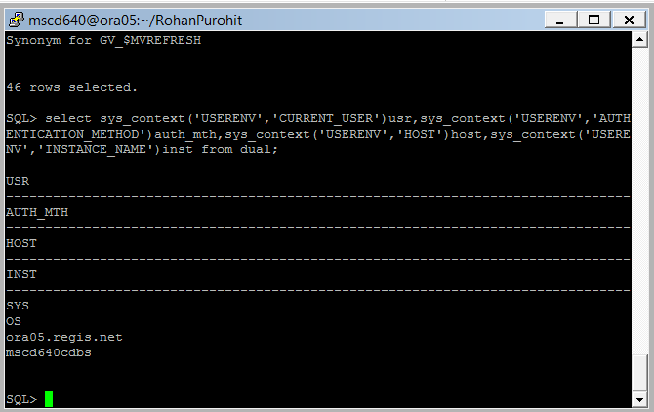
b. Review the output from the above query.
i. What is the name of the instance returned in the field INSTANCE_NAME?
mscd640cdbs
ii. Why is it different than your pluggable database?
It is the container level database mscd640cdbs rather than the pluggable database which for me is mscd640x40pdb10.
-----------------------------------------------------------------------------------
7. Display currently connected users.
See pages 265-268 in the book.
- Ex: SQL> select
count(*), username
from v$session
group by username;
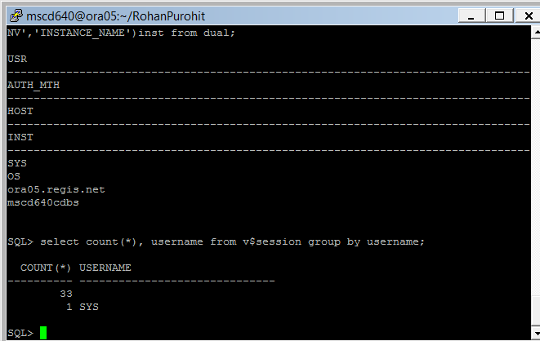
- Exit SQLPlus
-----------------------------------------------------------------------------------

8.
- Display SQL currently in memory. Run this SQL first as your ADMIN user. After running the SQL as your ADMIN user, from your SQL session issue the following SQL to connect to the SYS user and run the same SQL. Note your output and answer the questions in (b) below.
See page 265-272 in the book.

- From the database server command line change directory (cd) to your student directory under $HOME.

- Logon to your assigned pluggable database using your ADMIN username.
Replace the example username/password and pdb# with your assigned user, password, and db.
Ex: [mscd640@ora05 ~]$ sqlplus adminxx/adminxx@msc640xpdbxx

- as your ADMIN user run the following SQL:
Ex: SQL> @$HOME/MSCD640_Scripts/LAB3_Ex8a_3.sql
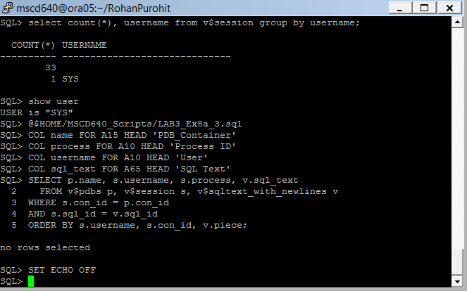 iii. From your SQL session connect as sysdba to the ROOT containter:
SQL> conn / as sysdba;

- Run the SQL script from step 8a_iii again while connected as sysdba. If other users are connected and issuing queries information will be displayed.

- The output from (iii and iv) above details a Process ID column from the V$SESSION view. What does the Process ID column signify? Hint: For clarification on the V$SESSION view, from your internet browser perform a search for the oracle 12c view V$SESSION. This search should display a list of various web pages detailing the Oracle 12c Database, object structures and object definitions.
The v$process view is used to provide the associated operating system process id (SPID) for each session

-----------------------------------------------------------------------------------
9. Alter your current session and set the container to your pluggable database.

- Before altering your session display the current container. You should be sitting in the CDB$ROOT container.
Ex: SQL> show con_name
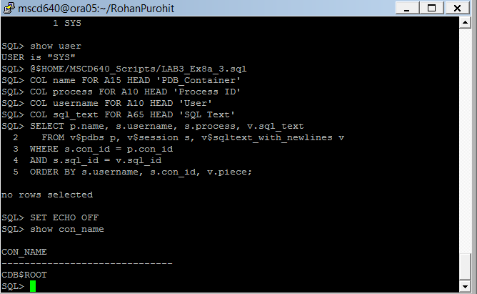

- Alter your SQL session to move to your pluggable database container.
replace the xx in the container name with your pluggable database number
Ex: SQL> alter session set container = msc640xpdbxx;

- Verify you are now sitting in your pluggable database container.
Ex: SQL> show con_name

Your pluggable database name should be displayed on the screen. If not, repeat step (b) above.

- Verify you are still connected as the sys user.
Ex: SQL> show user
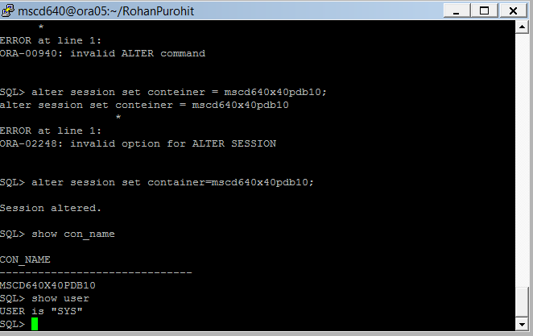
The user SYS should be displayed.

- Display extent information related to your INV_USER user. Note: Be patient as the query may take a little bit of time to return based on server activity.
Ex: SQL> @$HOME/MSCD640_Scripts/LAB3_Ex9_3.sql
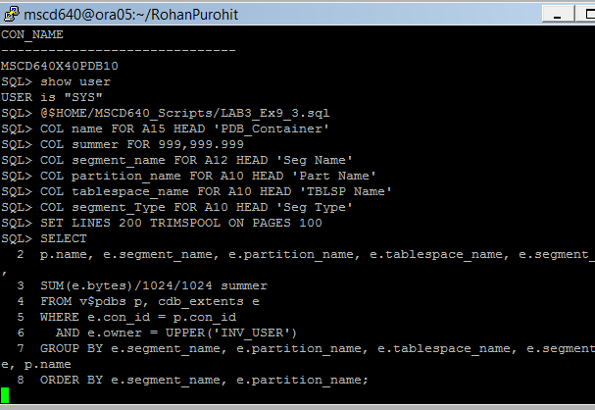
-----------------------------------------------------------------------------------

10. Generate a script to display row counts for the INV_USER tables.

- If not sitting in your student directory as requested exit from SQLPlus and cd to your student directory as defined in Exercise 1. The script will spool to the current directory you are sitting in on the database server.
See pages 270-271 in the book.

- Run the following SQL to generate a sql command file named inv_user_row_count.sql in your current directory.
Ex: SQL> @$HOME/MSCD640_Scripts/LAB3_Ex10_b.sql
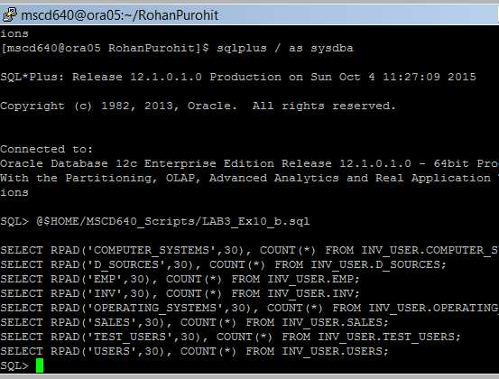
- Run the script generated in the prior step to show the row counts.
Ex: SQL>@inv_user_row_count.sql
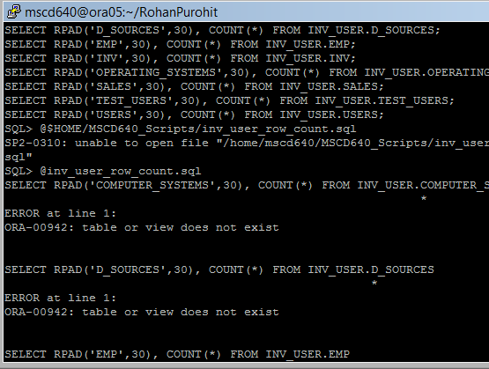
-----------------------------------------------------------------------------------
12. For this step, connect as INV_USER. Are there any foreign key columns for this user without a corresponding index?
See pages 272-274 in the book.

This exercise and following exercises use the inv_user created in a previous lab. If you don’t remember the password for user inv_user, reset the password to a password of your choice. To reset a user’s password issue the following statement replacing the words your new password with a password of your choice:

SQL> alter user inv_user identified by <your new password>;

- From your SQL Session connect as user INV_USER in your pluggable database.

(add your inv_user password in the connect string and replace the xx in the xpdb name with your pluggable database number)
SQL> conn inv_user/<your new password>@msc640xpdbxx
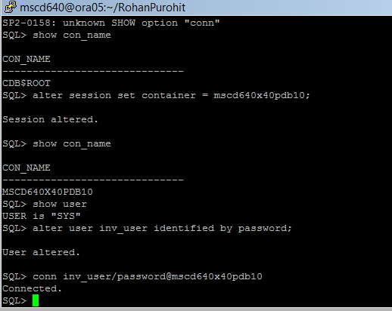
- Run the following script to display foreign key column constraints for user INV_USER.
Ex: SQL> @$HOME/MSCD640_Scripts/LAB3_Ex12_b.sql
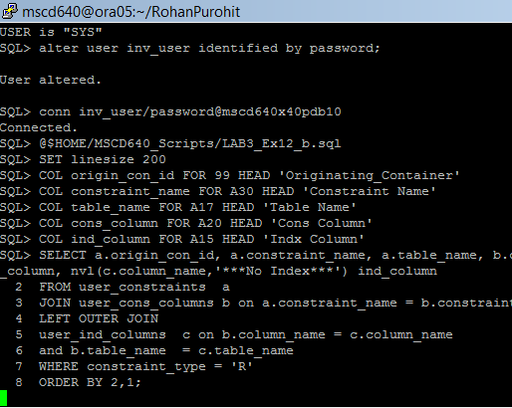
-----------------------------------------------------------------------------------

13. Show the various constraints for a user and table.
See pages 272-274 in the book.

- From the SQL prompt, connect as your admin user to your pluggable database container.
Ex: (replace the xx in the username/password and xpdb name with your pluggable database number)
SQL> conn adminxx/adminxx@msc640xpdbxx

- Run the following script from your SQL session. The user will be requested to enter a table owner name and a table name. Answer the prompts as defined below:
When prompted for the value of owner enter inv_user
When prompted for the value of table name enter computer_systems

Ex: SQL> @$HOME/MSCD640_Scripts/LAB3_Ex13_b.sql
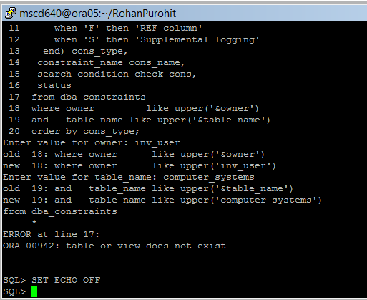
-----------------------------------------------------------------------------------
14. As your ADMIN user, display PK and FK information for a table.
See pages 272-274 in the book.

Run the following script from your SQL session. The user will be requested to enter a table owner name and a table name. Answer the prompts as defined below:
When prompted for the value of owner enter inv_user
When prompted for the value of table name enter computer_systems

Ex: SQL> @$HOME/MSCD640_Scripts/LAB3_Ex14.sql
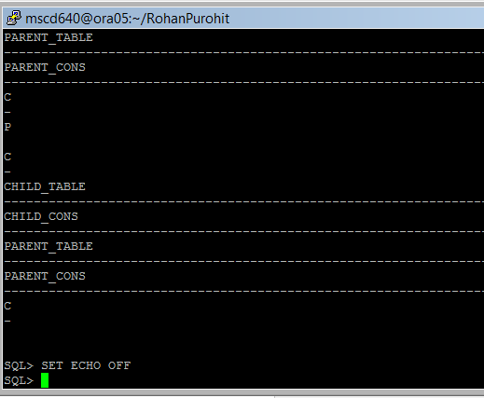
-----------------------------------------------------------------------------------

15. As your ADMIN user run the following script to display granted roles for your pdb users (exluding SYS and SYSTEM).
Ex: SQL> @$HOME/MSCD640_Scripts/LAB3_Ex15.sql
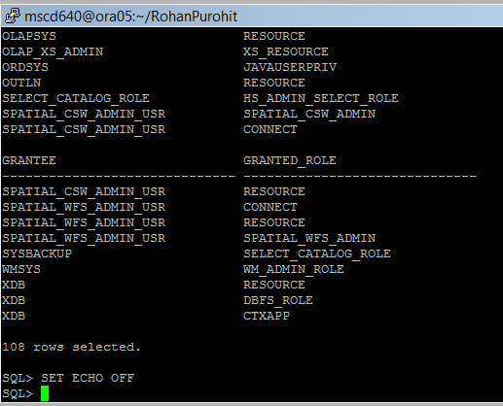
-----------------------------------------------------------------------------------
16. Run the following script as your ADMIN user display system privileges granted to the INV_USER user.
When prompted for value of grantee enter inv_user

Ex: SQL> @$HOME/MSCD640_Scripts/LAB3_Ex16.sql
-----------------------------------------------------------------------------------

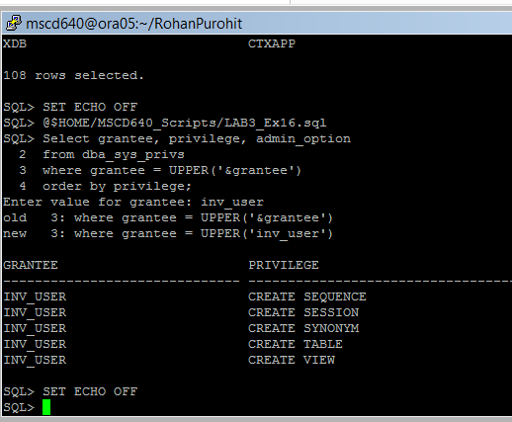
17. From your SQL session connect to your APP_MGMT user and Run the following script to display the table privileges are granted to APP_MGMT user. If you don’t remember the password for your APP_MGMT user reset the password by issuing the following statement as your ADMIN user setting a new password of your choice.

SQL> alter user app_mgmt identified by <your new password>;

- connect as APP_MGMT to your PDB from within your SQL session.
Replace the xx in the pdb name with your assigned pdb number
Ex: SQL> conn app_mgmt/foo@msc640xpdbxx
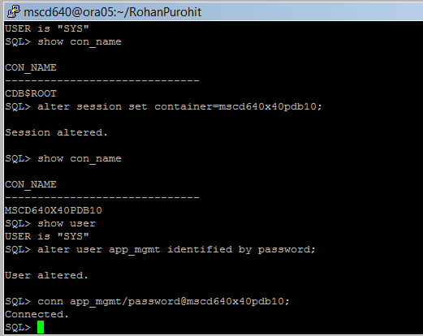
- Run the following query to view the object privileges granted to APP_MGMT user.
Ex: SQL> @$HOME/MSCD640_Scripts/LAB3_Ex17.sql
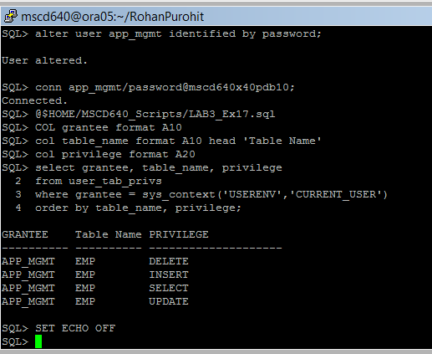
- Connect as your admin user to your pdb.
Ex: (replace the xx in the username/password and xpdb name with your pluggable database number)
SQL> conn adminxx/adminxx@msc640xpdbxx

-----------------------------------------------------------------------------------
Lab 3, Part 2: Large Objects
Read Chapter 11 in the book.
-----------------------------------------------------------------------------------
18.
- As your ADMIN user, verify the tablespace names and segment space management usage in your database:
Ex: SQL> select tablespace_name, segment_space_management
from cdb_tablespaces;

If tab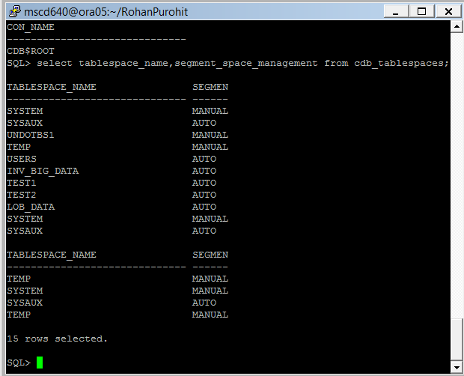lespace LOB_DATA is listed in the output from (a) above go to exercise 19, continue with step (b) below.
Yes LOB_DATA is created for me from past exercises.
- Create the LOB tablespace. Be patient, it may take a little time to create.
Replace the xx in the datafile pdb name with your pdb number.
SQL> create tablespace lob_data
datafile '/640/oracle/product/12.1.0/oradata/mscd640cdb/msc640xpdbxx/lob_data01.dbf'
size 1000m
extent management local
uniform size 1m
segment space management auto;

- Confirm the tablespace now exists:
Ex: SQL> select tablespace_name from cdb_tablespaces;

- Grant INV_USER privileges on tablespace log
Ex: SQL> alter user inv_user quota unlimited on lob_data;
-----------------------------------------------------------------------------------

19. Are securefiles allowed in your database.
See page 280 in the book.

SQL> show parameter db_securefile
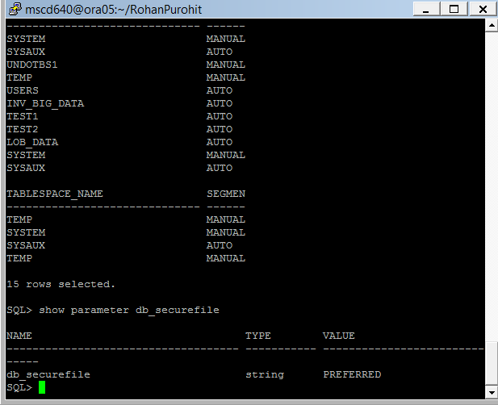
-----------------------------------------------------------------------------------

20. Connect as INV_USER and use LOB features.
See pages 281-283 in the book.

add your inv_user password in the connect string and replace the xx in the xpdb name with your pluggable database number
- SQL> connect inv_user/<password>@msc640xpdbxx

SQL> create table patchmain(
patch_id number
,patch_desc clob)
tablespace users;

- Verify the table build:
select table_name, segment_name ,index_name ,securefile ,in_row
from user_lobs;
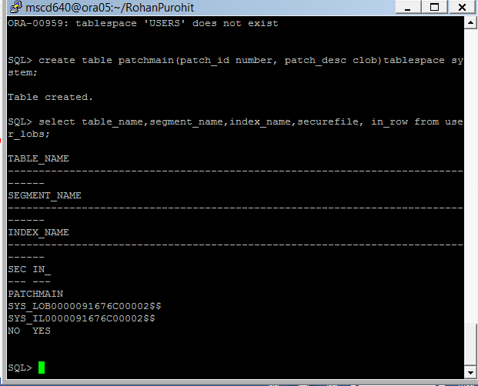
-----------------------------------------------------------------------------------

21. Drop the patchmain table and recreate it using securefiles.
See pages 284 in the book.

- Ex: SQL> drop table patchmain purge;
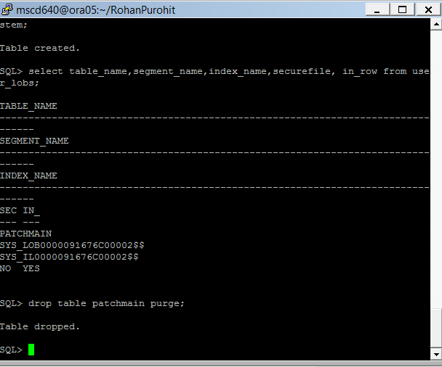
- Recreate the patchman table.
Ex: SQL> create table patchmain(
patch_id number
,patch_desc clob)
lob(patch_desc) store as securefile (tablespace LOB_DATA);
I tried to use this statement but my LOB_DATA could not be read. I got a no LOB_DATA exists but I verified that it was there in the tablespaces list.
I tried to use this statement with the SYSTEM tablespace but I could not use securefile LOB with system tablespace.
- Verify the table build:
Ex: SQL> Select segment_name ,segment_type ,segment_subtype
from user_segments;
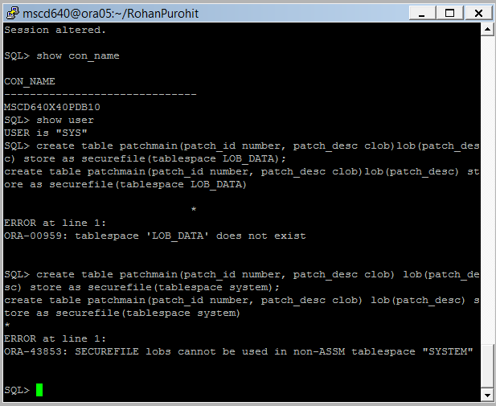
- Why don’t you see any segment data for the newly created table?

- Insert a row into your patchman table:
Ex: SQL> insert into patchmain values(1,'lob');

- Re-verify the segment space utilized:
Ex: SQL> select segment_name, segment_type ,segment_subtype
from user_segments;

- Save your changes.
Ex: SQL> commit;
-----------------------------------------------------------------------------------
22. What are the pros/cons to storing a LOB inline versus out of line?
See page 288-289 in the book.
The main advantage of storing a LOB in row is that small LOBS (<4000 characters) require less I/O because Oracel doesn’t have to search out of row for the LOB data. However, the disadvantage of storing LOB’s in row is that table row sizes are potentially longer. This can affect the performance of full table scans, range scans and updates to columns other than the LOB column. In these situations you might want to disable storage in a row.
-----------------------------------------------------------------------------------
23. How much space are LOB columns consuming in the INV_USER schema:

Ex: SQL> select a.table_name, a.column_name, a.segment_name, a.index_name
,b.bytes/1024/1024 meg_bytes
from user_lobs a, user_segments b
where a.segment_name = b.segment_name;
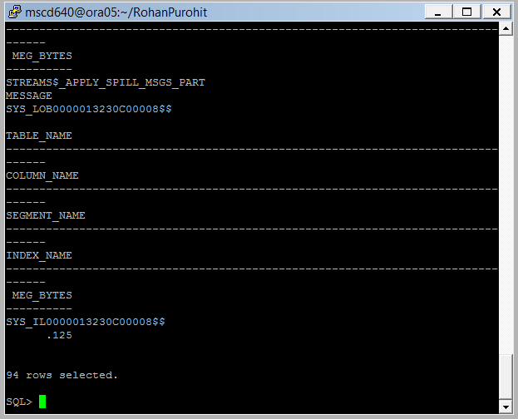
24. Exit SQLPlus.

Lab 3, Part 3: Partitioning
Read Chapter 12 in the book.
-----------------------------------------------------------------------------------
24. How do the terms “divide” and “conquer” apply to partitioning?
Partitioning addresses key issues in supporting very large tables and indexes by letting you decompose them into smaller and more manageable pieces called PARTITIONS. SQL queries and DML statements do not need to be modified in order to access partitioned tables. However, after partitions are defined, DDL statements can access and manipulate individuals partitions rather than entire tables or indexes.
-----------------------------------------------------------------------------------
25.
- Logon to your pluggable database as your ADMIN user.
Ex: (replace the xx in the username/password and xpdb name with your pluggable database number)
[mscd640@ora05 bjwaddoups]$ sqlplus adminxx/adminxx@msc640xpdbxx

- As your ADMIN user query for any tables in your database that potentially qualify as partitioning candidates.
See pages 304-305 in the book.
Ex: SQL> select * from (
select
owner
,segment_name
,segment_type
,partition_name
,sum(bytes)/1024/1024 meg_tot
from dba_segments
group by owner, segment_name, segment_type, partition_name
order by sum(extents) desc)
where rownum <= 10;
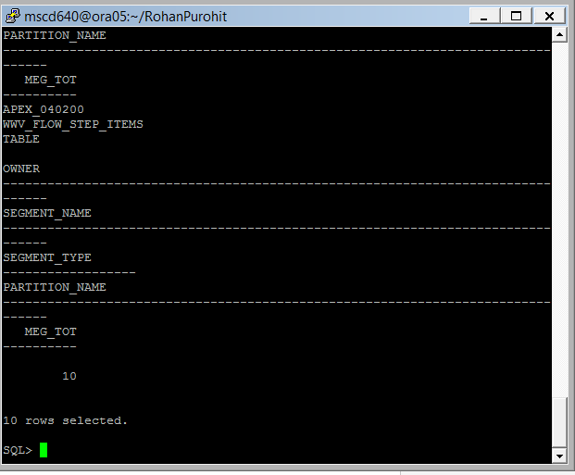
-----------------------------------------------------------------------------------

26. Create a partitioned table in the INV_USER schema.
See pages 306-307 in the book.

- From your SQL session connect as your INV_USER account.
Ex: (add your inv_user password in the connect string and replace the xx in the xpdb name with your pluggable database number)
SQL> conn inv_user/<password>@msc640xpdbxx

- Run the following query to create the partitioned table.
Ex: SQL> create table f_sales
(sales_amt number
,d_date_id number
)
partition by range (d_date_id)(
partition p_2012 values less than (20120101),
partition p_2013 values less than (20140101),
partition p_max values less than (maxvalue)
) tablespace users;
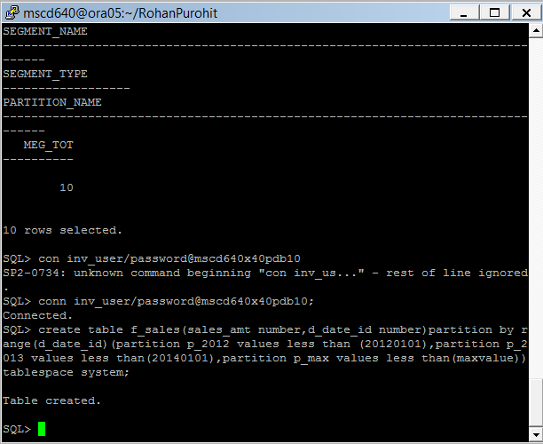
- Verify the partitioned table:
Ex: SQL> select
table_name
,partitioning_type
,def_tablespace_name
from user_part_tables
where table_name='F_SALES';
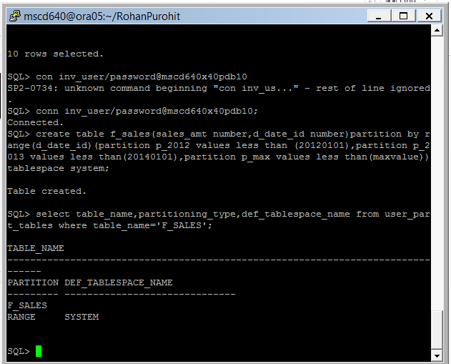
-----------------------------------------------------------------------------------

27. Verify the partitions were created with the ranges you specified.
See page 307 in the book.
Ex: SQL> select
table_name
,partition_name
,high_value
from user_tab_partitions
where table_name = 'F_SALES'
order by
table_name, partition_name;
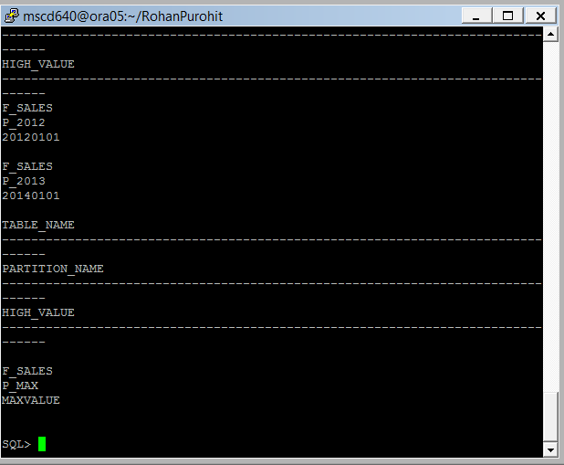
-----------------------------------------------------------------------------------

28. Insert some data into your partitioned table:
Ex:
SQL> insert into f_sales values(1, 20090615);
SQL> insert into f_sales values(1, 20110101);
SQL> insert into f_sales values(1, 20110215);
SQL> insert into f_sales values(1, 20140101);
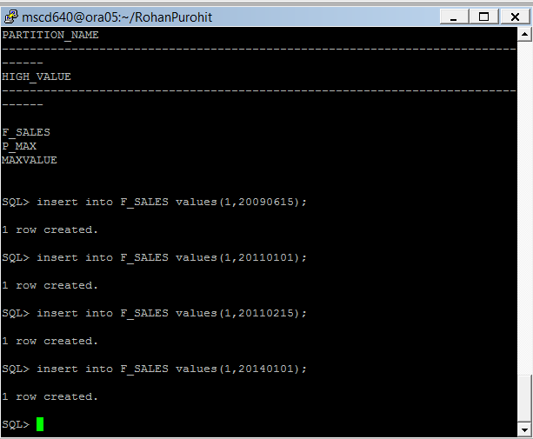
-----------------------------------------------------------------------------------
29. Create a report on the partitions.
See page 274 in the book.
- Ex: SQL> set linesize 200
COL segment_name format a25
COL segment_Type format a25
COL partition_name format a30
select segment_name, segment_type, partition_name
from user_segments
where partition_name is not null;
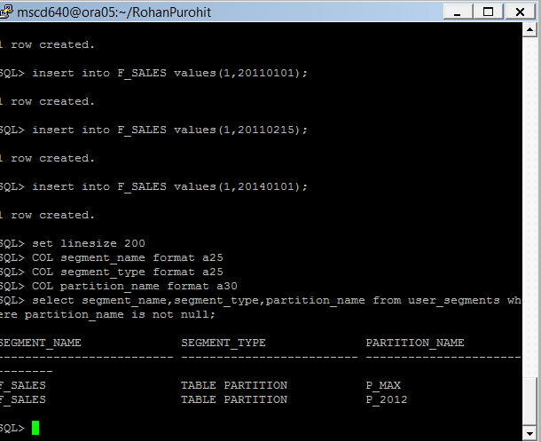
- Reset the linesize to 80 columns.
Ex: SQL> set linesize 80
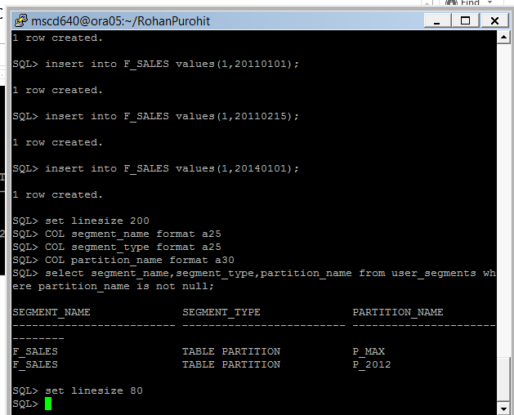
-----------------------------------------------------------------------------------
30.
- How many rows are in each partition?
Ex: SQL> select count(*) from f_sales partition(p_2012);
SQL> select count(*) from f_sales partition(p_2013);
SQL> select count(*) from f_sales partition(p_max);
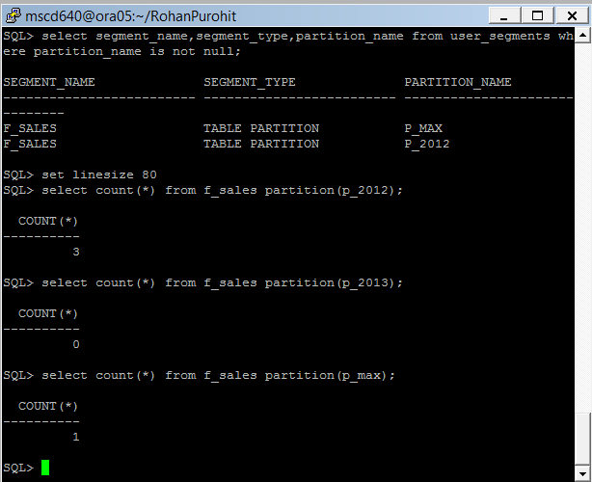
- Delete from one partition:
Ex: SQL> delete from f_sales partition(p_max);

- Verify:
Ex: SQL> select count(*) from f_sales partition(p_max);

- How many rows are there in the entire table (all partitions):
Ex: SQL> select count(*) from f_sales;
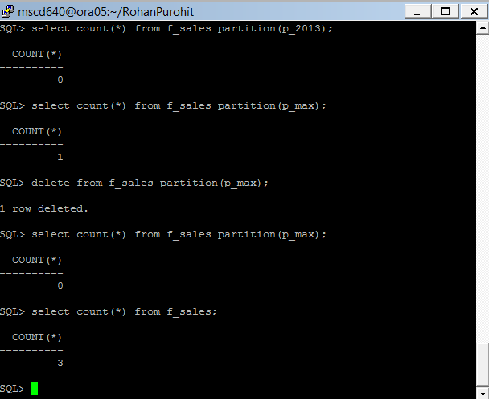
-----------------------------------------------------------------------------------
31. Drop the F_SALES table and recreate it partitioned by timestamp.
See page 309 in the book.

- Drop f_sales table.
Ex: SQL> drop table f_sales purge;
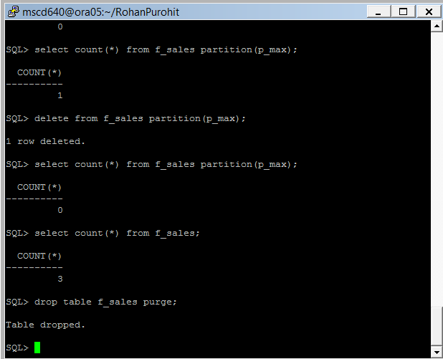
- Create f_sales partitioned by timestamp.
Ex: SQL> create table f_sales
(reg_count number
,d_date_dtt timestamp
)
partition by range (d_date_dtt)(
partition p_2010 values less than (to_date('01-jan-2012','dd-mon-yyyy')),
partition p_2011 values less than (to_date('01-jan-2013','dd-mon-yyyy')),
partition p_max values less than (maxvalue)
) tablespace users;
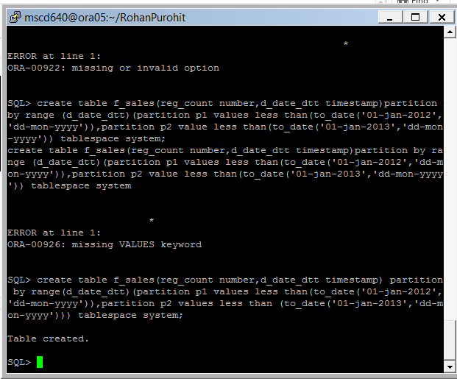
-----------------------------------------------------------------------------------
32. Insert data into the partitioned table:
Ex: SQL> insert into f_sales values (1, sysdate);
SQL> insert into f_sales values(2, add_months(sysdate,-20));
SQL> insert into f_sales values(3, '01-jan-2012');
I could not insert data into any of my partitions. I think this has to do with me not being able to write to any tablespaces.
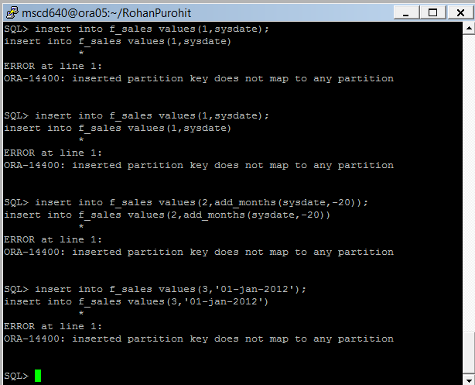
-----------------------------------------------------------------------------------
33. What does the row count look like for the partitioned table:
Ex: SQL> select count(*) from f_sales partition(p_2010);
SQL> select count(*) from f_sales partition(p_2011);
SQL> select count(*) from f_sales partition(p_max);
I correctly get zero rows for data in the two partitions I created earlier.
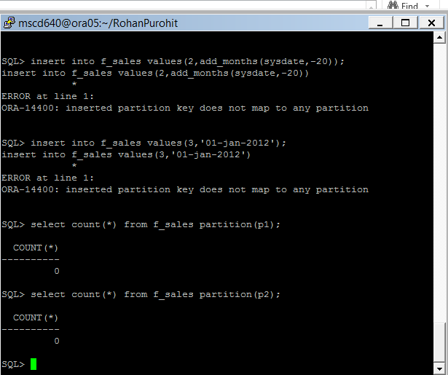
-----------------------------------------------------------------------------------
34. Create a table partitioned by list.
See page 313 in the book.

- Drop f_sales table.
Ex: SQL> drop table f_sales purge;
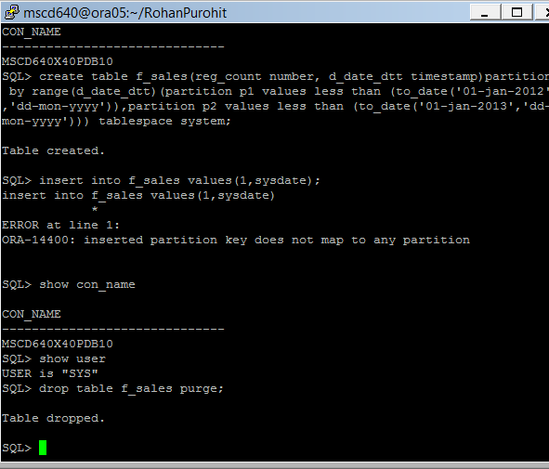
- Create f_sales as a table partitioned by list.
Ex: SQL> create table f_sales
(sales_amt number
,d_date_id number
,state_code varchar2(3)
)
partition by list (state_code)
( partition reg_west values ('AZ','CA','CO','MT','OR','ID','UT','NV')
,partition reg_mid values ('IA','KS','MI','MN','MO','NE','OH','ND')
,partition reg_rest values (default)
) tablespace users;

- Verify f_sales table creation:
Ex: SQL> select table_name
,partition_name
,high_value
from user_tab_partitions
where table_name = 'F_SALES'
order by 1;
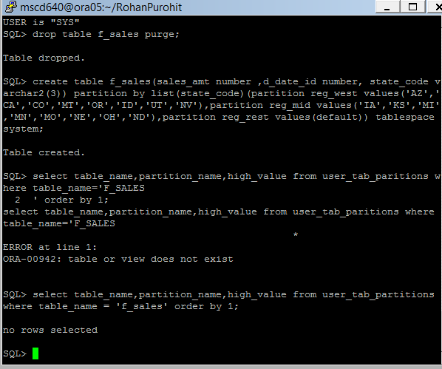
-----------------------------------------------------------------------------------
35. Create a table partitioned by hash.
See page 313-314 in the book.

- Drop the f_sales table.
Ex: SQL> drop table f_sales purge;
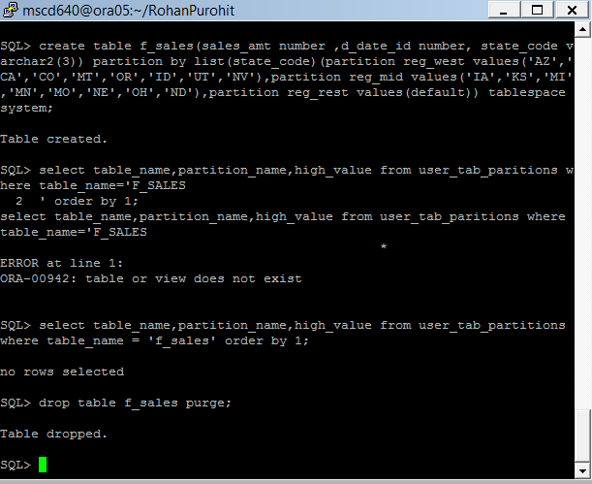
- Recreate f_sales as a table partitioned by hash.
Ex: SQL> create table f_sales(
sales_id number primary key
,sales_amt number)
partition by hash(sales_id)
tablespace users;

(We are eliminating the STORE IN clause. All partitions will be placed in your default tablespace. In the real world each partitions would be in their own tablespace.)

- Verify the table creation.
Ex: SQL> select table_name, partitioning_type, status from user_part_tables;
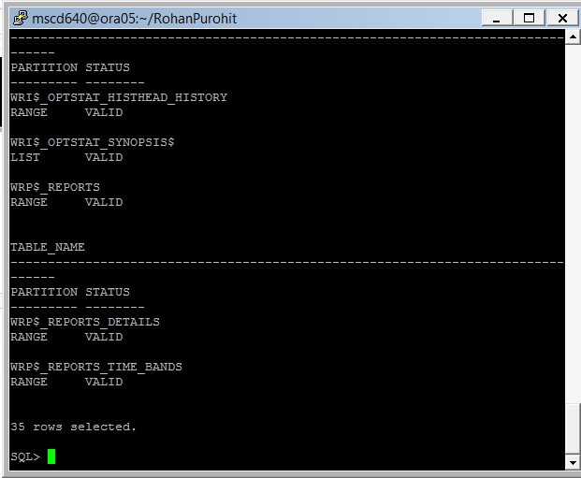
- Save your changes.
Ex: SQL> commit;
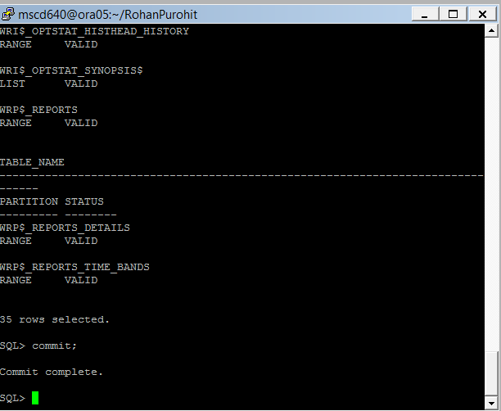
- Exit SQLPlus.
-----------------------------------------------------------------------------------
Lab 3, Part 4: Data Pump
Read Chapter 13 in the book.
-----------------------------------------------------------------------------------
36. Ensure you are sitting in your /home/mscd640/student name directory before continuing with your lab. The rest of Lab3 must be performed on the ora05 database server.

- Logon to your pluggable database as your ADMIN user.
Ex: (replace the xx in the username/password and xpdb name with your pluggable database number)
[mscd640@ora05 bjwaddoups]$ sqlplus adminxx/adminxx@msc640xpdbxx

- Create a directory object in your pluggable database. The directory object will reference your student directory on the database server.
See pages 347 in the book. Enter your student name directory where indicated, without brackets or spaces. Your student directory will be the physical location for your logical database directory.

Ex: SQL> create or replace directory dp as '/home/mscd640/<student name directory>';

- Verify that the directory was created in the database. Reference the directory name in UPPERCASE:

Ex: SQL> select * from cdb_directories where directory_name='DP';
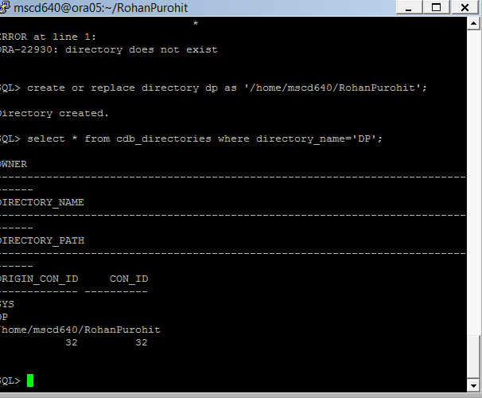
-----------------------------------------------------------------------------------
37. Grant permissions to the directory object to INV_USER.
See page 347 in the book. Be sure to reference the data pump directory alias name “DP’ in uppercase.

SQL> grant read, write on directory DP to inv_user;
Grant succeeded.
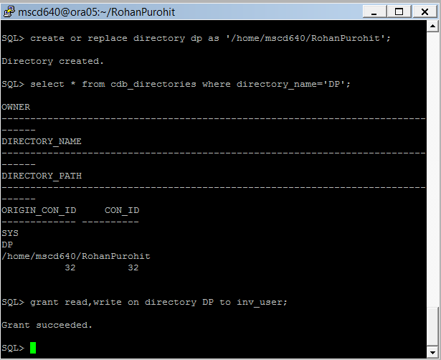

-----------------------------------------------------------------------------------
38.
- Connect as your INV_USER.

add your inv_user password in the connect string and replace the xx in the xpdb name with your pluggable database number
SQL> conn inv_user/<password>@msc640xpdbxx

- create a table and populate it with data.
Ex:
SQL> create table tester(tester_id number) tablespace users;
SQL> insert into tester values (123456);
SQL> insert into tester select * from tester;
SQL> insert into tester select * from tester;
SQL> insert into tester select * from tester;
SQL> insert into tester select * from tester;
SQL> commit;

- confirm the table and table data.
Ex:
SQL> select * from tester;
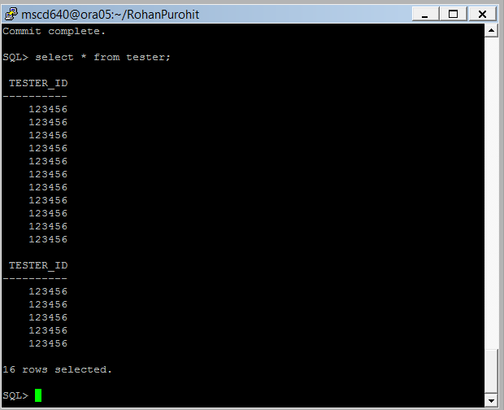
- Exit SQLPlus.
-----------------------------------------------------------------------------------

39. From the operating system prompt, run the expdp utility. The exported data dump file will be written to your student directory.
See page 351 in the book.
(Update your inv_user password in the expdp statement, replace the xx your xpdb number and create your dmp and log files using your name as the filenames. See the “For example” for naming your dmp and log file)

- expdp inv_user/<password>@msc640xpdbxx directory=DP dumpfile=<your name>.dmp logfile=exp<your_name>.log tables=tester
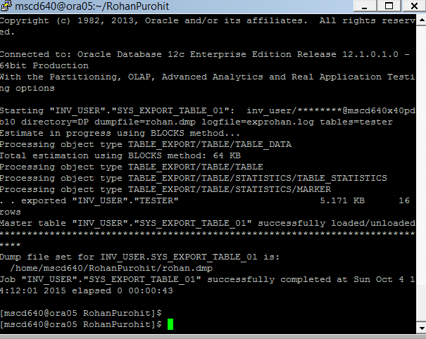

For example:
expdp inv_user/inv_user_pwd@msc640xpdbxx directory=DP dumpfile=barbara.dmp logfile=expbarbara.log tables=tester

- Review the files in your student directory.
Ex: [mscd640@ora05 bjwaddoups]$ ls –ltr
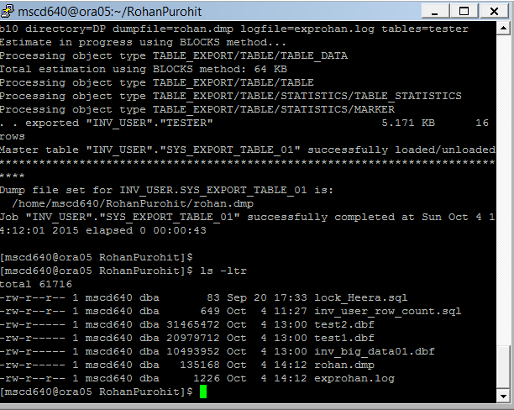

There should be two new files in your directory, the exported data is in the .dmp file and the log of the export process is in the .log file.

You cannot view the .dmp file, however you can review the log file by typing the ‘more’ command at the server command prompt:
Ex:
[mscd640@ora05 bjwaddoups]$ more expbjwaddoups.log
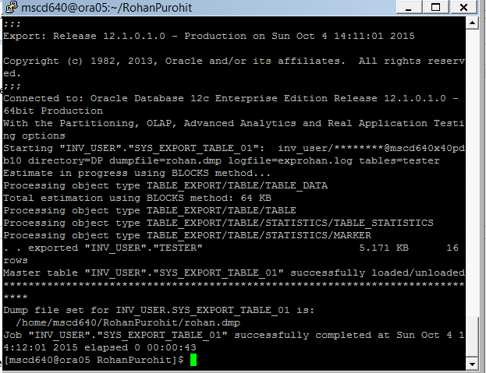

Now that the data is exported the tester table you will drop the original table recreate it by importing your exported data.
-----------------------------------------------------------------------------------
40. Login to SQL*Plus and drop the tester table:
(add your inv_user password in the connect string and replace the xx in the xpdb name with your pluggable database number)
Ex:
[mscd640@ora05 bjwaddoups]$ sqlplus inv_user/password@msc640xpdbxx

- Next, drop the old tester table and purge the contents.
Ex:
SQL> drop table tester purge;

- Verify that it’s gone:
Ex:
SQL> desc tester;
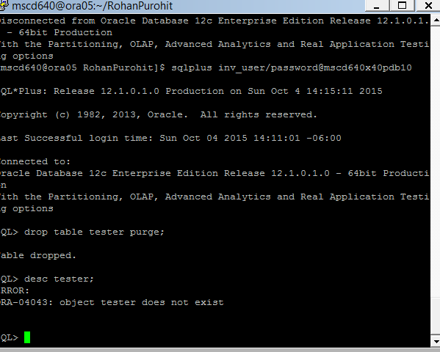
The following error should appear confirming the object does not exist.
ORA-04043: object tester does not exist

- Exit SQLPlus.

-----------------------------------------------------------------------------------
41. A new tester table will be built in your pluggable database for the INV_USER using the impdp data pump process.

- Confirm you are still sitting in your student directory:
Ex:
[mscd640@ora05 bjwaddoups]$ pwd
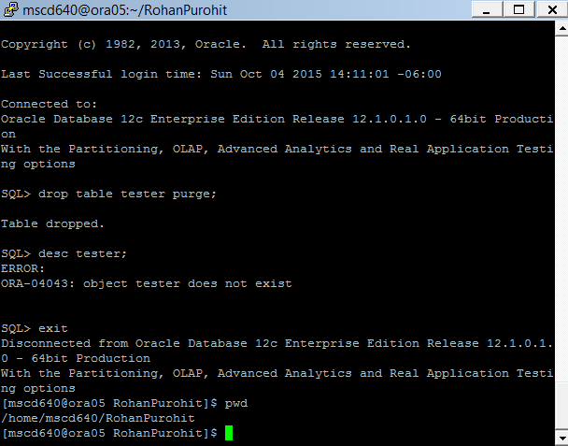
Your student directory path should be displayed.

- From the operating system prompt, run the impdp utility to import the table in the dump file.
See page 353 in the book.

add your inv_user password in the connect string and replace the xx in the xpdb name with your pluggable database number
See the “For example” for naming of your dump and log files.

impdp inv_user/<user password>@msc640xpdbxx directory=DP dumpfile=<your_name>.dmp logfile=imp<your_name>.log

For example:
impdp inv_user/inv_user_pwd@msc640xpdxx directory=DP dumpfile=bjwaddoups.dmp logfile=impbjwaddoups.log
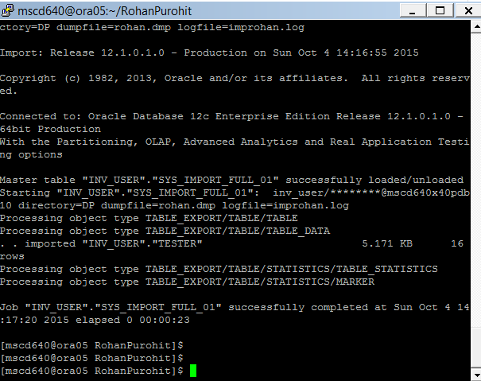
-----------------------------------------------------------------------------------

42. Logon to SQL*Plus as your INV_USER and see if the table has been imported:
- Ex: (add your inv_user password in the connect string and replace the xx in the xpdb name with your pluggable database number)

[mscd640@ora05 bjwaddoups]$ sqlplus inv_user/password@msc640xpdbxx

- SQL> select * from tester;
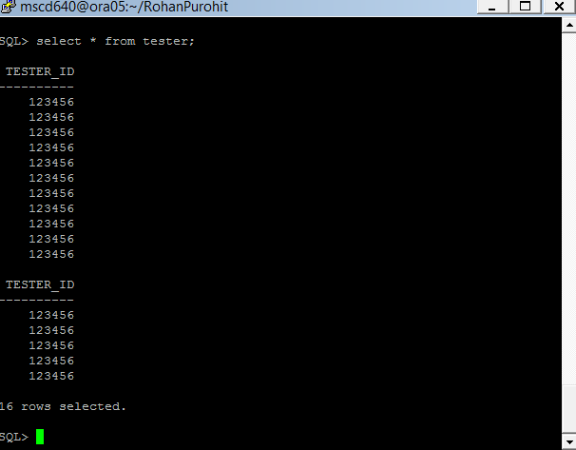
- Exit SQLPlus.
-----------------------------------------------------------------------------------
43. Delete your dmp and log files your student directory. From the operating system prompt type the following commands:

- Change location to your student directory if not already there.
Ex: [mscd640@ora05 bjwaddoups]$ cd /home/mscd640/bwaddoups

- Remove the .dmp and .log files by issuing the following commands from the server prompt replacing student name with the name of your student directory:
rm student name.dmp
rm impstudent name.log
rm expstudent name.log
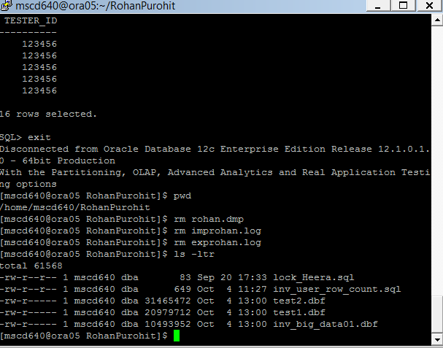
-----------------------------------------------------------------------------------
Lab 3, Part 5: External Tables
Read Chapter 14 in the book.
-----------------------------------------------------------------------------------
44. For this lab, there should be a file named ex.csv placed in the /home/mscd640 directory.
See page 388-389 in the book.

- Change directories to the mscd640 home directory:
Ex: ($HOME is the environment variable shortcut to the /home/mscd640 directory.)
[mscd640@ora05 ~]$ cd $HOME

- Display the contents of the ex.csv file:
Ex:
[mscd640@ora05 ~]$ cat ex.csv

Here are the expected contents of ex.csv:

5|2|0|0|12/04/2009|Half
6|1|0|1|03/31/2010|Quarter
7|4|0|1|05/07/2010|Full
8|1|1|0|04/30/2010|Quarter
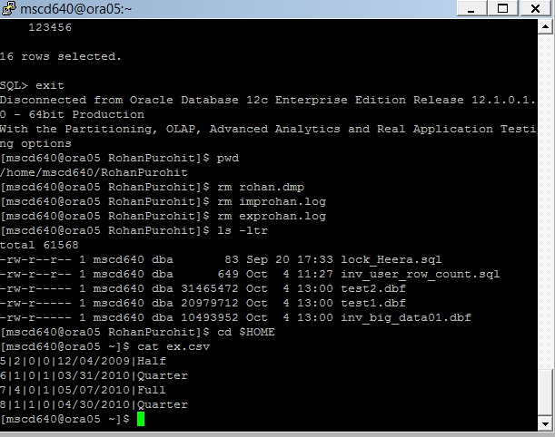
- Using the server command cp, copy the file to your student directory:
Ex:
cp ex.csv /home/mscd640/<your student dir name>/ ← Be sure to include the forward slash at the end of the cp statement.

-----------------------------------------------------------------------------------
45.
- Connect to your pluggable database as your ADMIN user.
(replace the xx in the username/password, and xpdb name with your pluggable database number)
Ex:
[mscd640@ora05 bjwaddoups]$ sqlplus adminxx/adminxx@msc640xpdbxx

- create a new directory object in your database and grant the appropriate privileges to your INV_USER.
See page 389 in the book.
Ex:
SQL> create or replace directory exa_dir as '/home/mscd640/<your student dir name>'; ← do NOT add a forward slash at the end of the directory name stored in the database table.

Ex: SQL> create or replace directory exa_dir as '/home/mscd640/bjwaddoups';

- Grant privileges to your INV_USER for read and write access to the new directory object.
Ex:
SQL> grant read, write on directory exa_dir to inv_user;
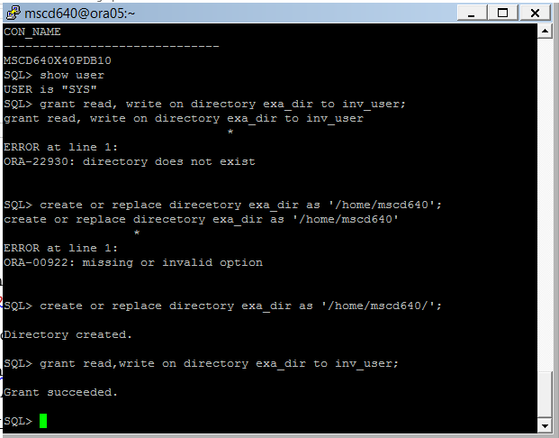
-----------------------------------------------------------------------------------

46. Create an external table reference in the database.
- From your SQLPlus session connect as INV_USER.
Ex: (add your inv_user password in the connect string and replace the xx in the xpdb name with your pluggable database number)

SQL> conn inv_user/<password>@msc640xpdbxx

- Cut and paste the following code in SQLPlue to create the external table in the INV_USER schema.
See pages 390 in the book.

create table exadata_et(
exa_id NUMBER
,machine_count NUMBER
,hide_flag NUMBER
,oracle NUMBER
,ship_date DATE
,rack_type VARCHAR2(32)
)
organization external (
type oracle_loader
default directory exa_dir
access parameters
(
records delimited by newline
fields terminated by '|'
missing field values are null
(exa_id
,machine_count
,hide_flag
,oracle
,ship_date char date_format date mask "mm/dd/yyyy"
,rack_type)
)
location ('ex.csv')
)
reject limit unlimited;
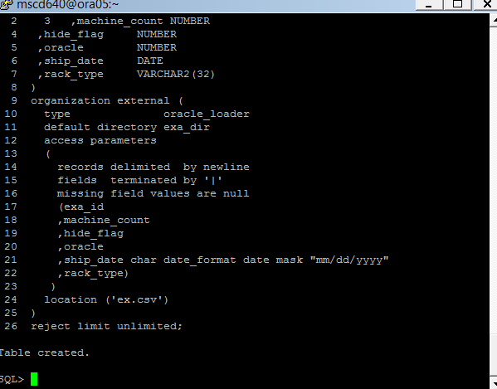
----------------------------------------------------------------------------------

47. Display the data in the external table:
Ex: SQL: Select * from exadata_et;

If the following error is returned then the ex.csv file has not been copied to your student directory as specified in step 44.c.
Go back to step 44.c and ensure the file has been copied to your student directory using the cp server command.

ERROR at line 1:
ORA-29913: error in executing ODCIEXTTABLEOPEN callout
ORA-29400: data cartridge error
KUP-04040: file ex.csv in EXA_DIR not found
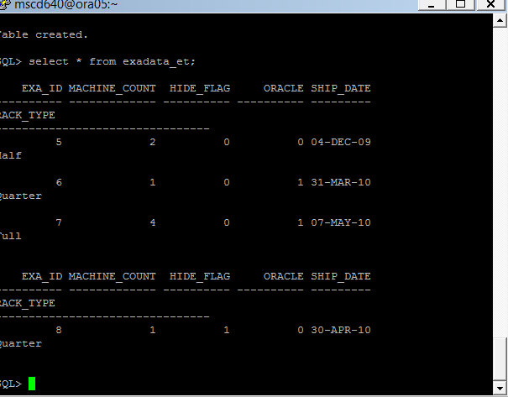
-----------------------------------------------------------------------------------

48. What are some practical uses for external tables?
External tables can be manipulated using SQL. Reads/loads for external tables can be paralleled.Loading a table from an external table is faster than SQL*Loader due to parallel query and DML.External tables do not require any database space; only the space consumed by the flat-files on the filesystem. Furthermore we can completely remove the need for staging tables altogether and use the tables directly in ETL code.
-----------------------------------------------------------------------------------
-----------------------------------------------------------------------------------
Lab 3, Part 6: Materialized Views
Read Chapter 15 in the book.
-----------------------------------------------------------------------------------
49. As your INV_USER drop (if it exists) the SALES table and recreate.
See pages 403-404 in the book.
- Show the current user:
Ex: SQL> show user

The user should display as INV_USER.

- Show the container name:
Ex: SQL> show con_name

Your msc640xpdbxx pluggable database name should be displayed. If not, exit from SQLPlus and log back in as your INV_USER.

- If the sales table exists, drop it:
Query for the sales table.
Ex: SQL> desc sales

If the Oracle error “ORA-04043 object sales does not exist” is returned go to step (e), otherwise continue to step (d).

- Drop and purge the sales table.
Ex:
SQL> drop table sales purge;

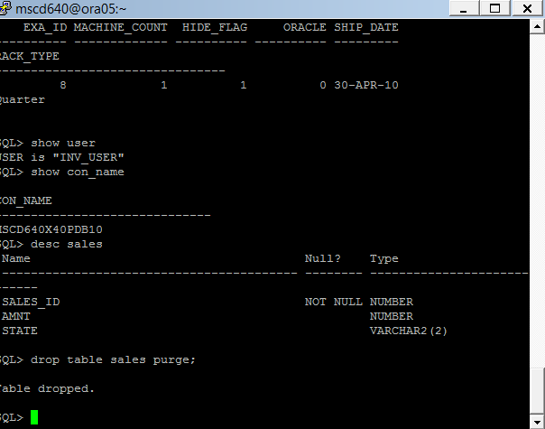

- Create the sales table using the below SQL:
Ex: SQL> create table sales(
sales_id number
,sales_amt number
,region_id number
,sales_dtt timestamp
,constraint sales_pk primary key(sales_id)
) tablespace users;
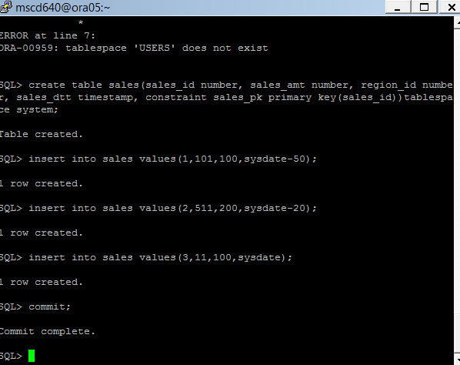
- Insert some data:
Ex: SQL> insert into sales values(1,101,100,sysdate-50);
SQL> insert into sales values(2,511,200,sysdate-20);
SQL> insert into sales values(3,11,100,sysdate);
SQL> commit;

- Verify the table and data:
Ex: SQL> select * from sales;
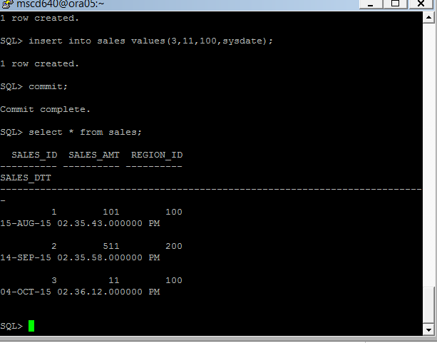
-----------------------------------------------------------------------------------

50. Create a materialized view based on the SALES table.
See page 407-409 in the book.

- From your SQLPlus session, connect as your ADMIN user in your pluggable database.
(replace the xx in the username/password and xpdb name with your pluggable database number)

SQL> conn adminxx/adminxx@msc640xpdbxx

- Grant INV_USER create privileges for materialized views.
Ex:
SQL> grant create materialized view to INV_USER:
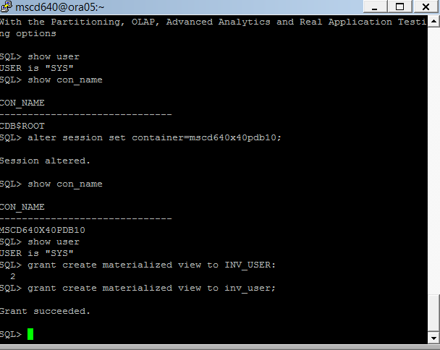
- From your SQLPlus session, connect to your INV_USER user in our pluggable database:
(Add the INV_USER password and replace the xx in the xpdb name with your pluggable database number)
Ex:
SQL> conn INV_USER/<password>@msc640xpdbxx

- As the INV_USER, create a materialized view using the below SQL:

create materialized view sales_mv
segment creation immediate
refresh
complete
on demand
as
select
sales_amt
,sales_dtt
from sales;
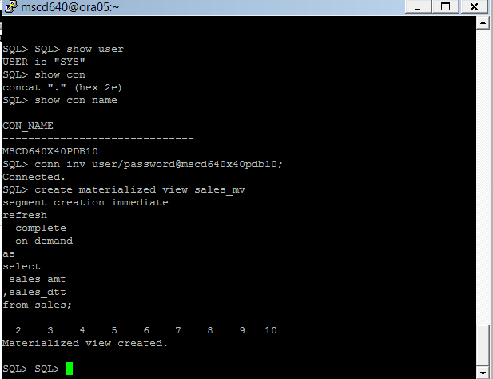
- Verify the materialized view using the following SQL:
Ex:
SQL> select
mview_name
,refresh_method
,refresh_mode
,build_mode
,fast_refreshable
from user_mviews
where mview_name = 'SALES_MV';
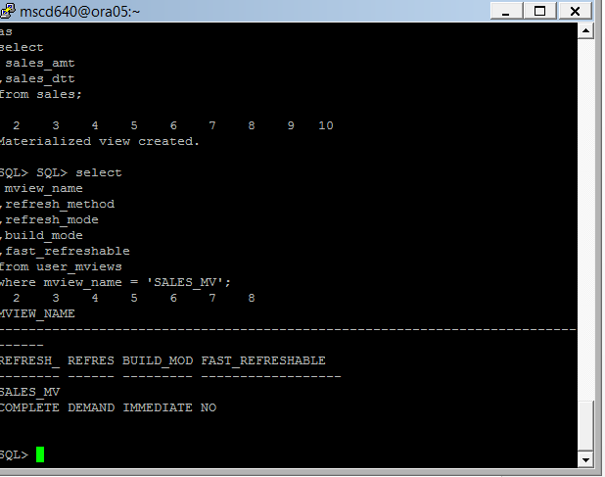

51. Insert data into the SALES and compare the table with the MV:

- Insert data into the Sales table:
Ex: SQL> insert into sales values(4,50,100,sysdate);
SQL> commit;

- Display all records in the sales table:
Ex: SQL> select * from sales;

- Display all the records in the sales materialized view:
Ex:
SQL> select * from sales_mv;
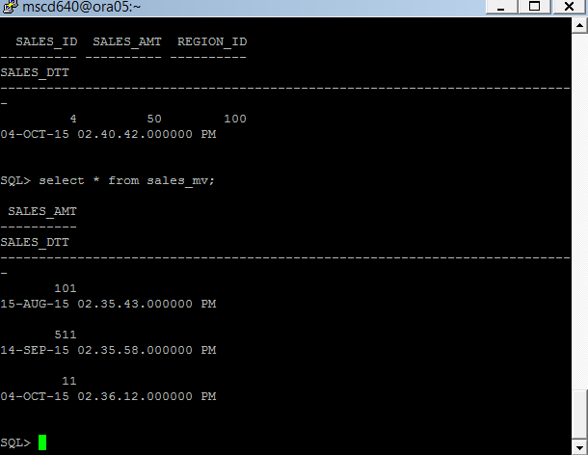
-----------------------------------------------------------------------------------

52. Refresh the SALES_MV.
See page 409 in the book.

- Use the dbms_mview package to refresh the materialized view:
Ex: SQL> exec dbms_mview.refresh('SALES_MV','C');
Stored Procedure completed successfully.
- Now select all the records from the materialized view:
Ex: SQL> select * from sales_mv;
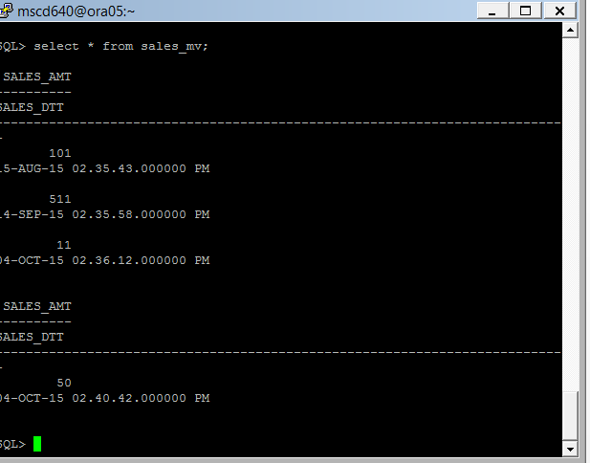
- Does the data in the materialized view match the data in the sales table?
Yes.
-----------------------------------------------------------------------------------
53. What are some practical uses for materialized views?
A materialized view allows you to execute a query at a point in time and store the result in a table. After the materialized view is initially populated you can later rerun the materialized view query and store fresh results in the underlying table. (Kuhn 403) The two main uses of materialized views are first to replicate data to offload query workloads to separate reporting databases and second to improve performance of queries by periodically computing and storing results of complex aggregations of data, which lets users query point in time results of complex aggregations. These are useful in computing historical data to see how a process calculated an algorithm over time and how the variables of that algorithm changed with each point in time. Secondly it helps produce a backtracking for complex changes to the database that occur over a set of specific transactions by providing snapshots of changes to the entity columns. Materialized vies allow for speeding up for write operations. Since indexes can be created on MV’s they are quite fast. To reduce index maintenance overhead materialized views can be created with indexes specified on them. MV’s also help in speeding read operations for complex joins; pivots can be speed up by creating indexes on the materialized views. It is particularly useful in reporting scenarios.
------------------------------------------------------------------------------------
54. Close your PDB.

- From your SQL session connect as sysdba.
Ex: SQL> conn / as sysdba

- Set the container to your pdb.
Replace the red xx in the container name to your assigned pdb number.
Ex: SQL> alter session set container=msc640xpdbxx ;

- Validate the container name is set to your pdb name.
Ex: SQL> show con_name

If the con_name value displayed is your container proceed to close your PDB, otherwise repeat steps (a) – (c) above.

- Close your PDB.
Ex: SQL> alter pluggable database close;
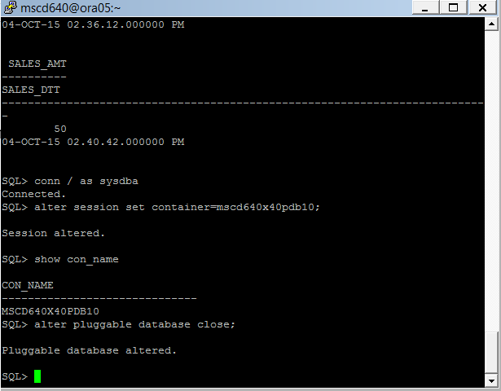

End of Lab 3!

